“Feature engineering,” involves computing explicit features specified by experts, resulting in algorithms designed to detect specific lesions or predicting the presence of any level of diabetic retinopathy.5 Deep learning6 is a machine learning technique that avoids such engineering by learning the most predictive features directly from the images given a large data set of labeled examples. This technique uses an optimization algorithm called back-propagation to indicate how a machine should change its internal parameters to best predict the desired output of an image. Some of the papers using deep learning algorithms to create models are as follows:

1. Development and Validation of a Deep Learning Algorithm for Detection of Diabetic Retinopathy in Retinal Fundus Photographs

* Authors: Varun Gulshan et al. 2016
* Objective: To apply deep learning to create an algorithm for automated detection of diabetic retinopathy and diabetic macular edema in retinal fundus photographs.
* Method: CNN was implemented using Inception-v3 architecture proposed by Szegedy et al. The optimization algorithm used to train the network weights was a distributed stochastic gradient descent implementation by Dean et al.16 To speed up the training, batch normalization7 as well as preinitialization using weights from the same network trained to classify objects in the ImageNet data set17 were used. An ensemble19 of 10 networks trained on the same data was used, and the final prediction was computed by a linear average over the predictions of the ensemble.
* Data: The EyePACS-1 data set consisted of 9963 images and Messidor-2 data set had 1748 images

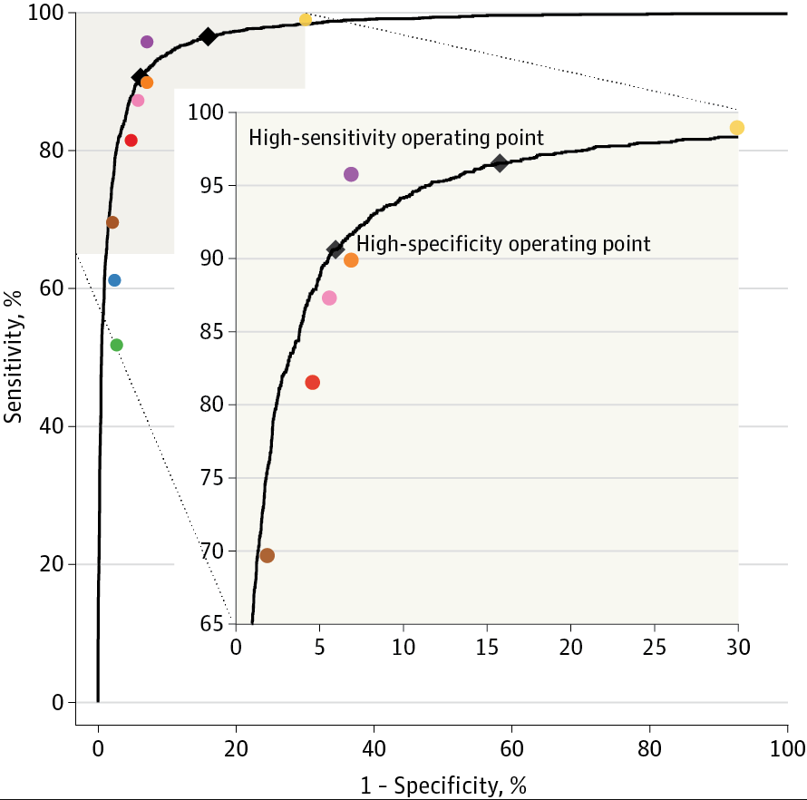

* Result: Performance of the algorithm (black curve) and ophthalmologists (colored circles) is shown in the figure. The black diamonds highlight the performance of the algorithm at the high-sensitivity and high-specificity operating points:
  + High-sensitivity operating point: specificity was 84.0% and sensitivity was 96.7%.
  + High-specificity operating point: specificity was 93.8% and sensitivity was 90.7%
  + The area under the receiver operating characteristic curve was 97.4%

1. Improved Automated Detection of Diabetic Retinopathy on a Publicly Available Dataset Through Integration of Deep Learning

* Authors: Michael David Abramoff et al 2016
* Objective: To compare performance of a deep-learning enhanced algorithm for automated detection of diabetic retinopathy.
* Method: A hybrid device applies a set of CNN-based detectors to each of the images in the exam. These detectors are trained and optimized to detect normal retinal anatomy, such as optic disc and fovea, as well as the lesions characteristic for DR, such as hemorrhages, exudates, and neovascularization. They are inspired by Alexnet23 and the Oxford Visual Geometry Group26 network architectures. The analysis software provides four types of outputs:
  + Negative: implying no or only mild DR present
  + rDR: implying rDR is present
  + vtDR: implying vtDR is present
  + Low exam quality: implying either protocol errors or low quality of the individual images.

If the index is above or equal to the vtDR threshold, a positive output for vtDR is returned. If the vtDR index is below this threshold, the rDR index is thresholded. If the rDR index is above or equal to this latter threshold a positive output for rDR is returned. If it is below the latter threshold an output of ‘‘negative’’ is returned**. The device was never trained on any of the Messidor-2 images.**

* Data: 10,000 to 1,250,000 unique samples, depending on the lesion to be detected are used for training. Messidor-2 data consisting of 1748 images is used for validation.
* Result: The device with CNN based detectors performed pretty good with results of:
  + vtDR: 100% sensitivity, 91% specificity and 0.989 AUC.
  + rDR: 96.8% sensitivity and 87.0% specificity

1. Fast convolutional neural network training using selective data sampling: Application to hemorrhage detection in color fundus images
   * Authors: van Grinsven et al 2016
   * Objective: a method to improve and speed-up the CNN training for medical image analysis tasks by dynamically selecting misclassified negative samples during training
   * Method: A dynamic CNN training strategy where informative normal samples are dynamically selected at each training epoch from a large pool of medical images. A dynamic weight is assigned to each pixel in the negative training pool indicating its informativeness level. After each CNN training epoch, the weight of each negative training pixel is updated. This process is repeated until a stopping criterion is reached. The final trained CNN is used to classify each pixel in the test images, resulting in a pixel probability map for each test image
   * Network details: The CNN architecture used in this study consists of five convolutional layers followed by rectified linear units (ReLUs) and spatial max-pooling. The final layers of the network consist of a fully connected layer and a final softmax classification layer.
   * Data: Kaggle and Messidor databases
   * Result: A decreased training time from 170 epochs to 60 epochs with an increased performance – on par with two human experts – was achieved with areas under the receiver operating characteristics curve of 0.894 and 0.972 on two data sets. The SeS CNN statistically outperformed the NSeS CNN on an independent test set
2. Convolutional Neural Networks for Diabetic Retinopathy
   * Authors: Pratt et al 2016
   * Objective: A network with CNN architecture and data augmentation which can identify the intricate features involved in the classification task such as micro-aneurysms, exudate and haemorrhages on the retina and consequently provide a diagnosis automatically and without user input
   * Method: Preprocessing tasks such as colour normalization and resizing were performed. The network was trained using stochastic gradient descent with Nestrov momentum. Afterwards, real-time dataaugmentation was used throughout training to improve the localisation ability of the network
   * Network details: The network starts with convolution blocks with activation and then batch normalisation after each convolution layer. As the number of feature maps increases they move to one batch normalisation per block. All maxpooling is performed with kernel size 3x3 and 2x2 strides. After the final convolutional block the network is flattened to one dimension. To avoid overfitting they used weighted class weights relative to the amount of images in each class. Likewise, they performed dropout on dense layers, to reduce overfitting, until they reached the dense five node classification layer which uses a softmax activation function to predict our classification. The leaky rectified linear unit13 activation function was used, applied with a value of 0.01, to stop over reliance on certain nodes in the network. Similarly, in the convolution layers, L2 regularisation was used for weight and biases. The network was also initialized with Gaussian initialisation to reduce initial training time. The loss function used to optimise was the widely used categorical cross-entropy function.
   * Data: Kaggle dataset
   * Result: a sensitivity of 95% and an accuracy of 75% on 5,000 validation images
3. Automated Identification of Diabetic Retinopathy Using Deep Learning
   * Authors: Gargeya et al 2017
   * Objective: to develop a data-driven deep learning algorithm to automate DR screening
   * Method: Image pixel values were scaled and downsized, and data augmentation and brightness and contrast enhancement were performed as preprocessing.
   * Network details: convolutional parameter layers learn iteratively filters that transform input images into hierarchical feature maps, learning discriminative features at varying spatial levels without the need for manually tuned parameters. each convolutional layer used batch normalization and the ReLU nonlinearity function to ensure smooth training and prevent overfitting, while using 2-class categorical cross-entropy loss for class discrimination
   * Data: Messidor 2 and E-Optha databases
   * Result: a 0.94 and 0.95 AUC score
4. Improved Microaneurysm Detection using Deep Neural Networks
   * Authors: Haloi et al 2016
   * Objective: a novel microaneurysm (MA) detection for early diabetic retinopathy screening using color fundus images
   * Method: Each pixel of the image is classified as either MA or non-MA using a deep neural network with dropout training procedure using maxout activation function. No preprocessing step or manual feature extraction is required
   * Network details: three convolutional layers each followed by a max-pooling layer and one fully connected layer. And a softmax layer on the top of the network with two neurons for MA and non-MA probability values
   * Data: Retinopathy Online Challenge (ROC) and Diaretdb1v2 database
   * Result: accuracy of 95% with sensitivity and specificity of 97% and 94% respectively on Messidor dataset